**EXPERIMENT # 3**

**DEMONSTRATION OF FOUR**

**STROKE DIESEL ENGINE**

**OR**

**COMPRESSION IGNITION**

Diesel engine may be designed as either two stroke or four stroke cycles.

* **A Four Stroke Diesel Engine** is an internal combustion engine in which the piston completes four separate strokes while turning a crankshaft. A stroke refers to the full travel of the piston along the cylinder, in either direction.

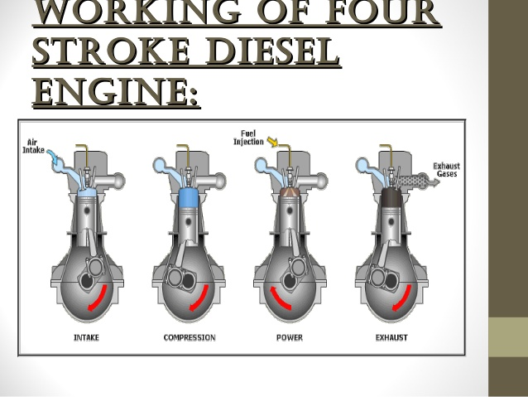**Diagram of Four Stroke Diesel Engine:**

**Processes:**

The four processes of four stroke diesel engine are given below in following:

* Suction stroke
* Compression stroke
* Power stroke / Expansion stroke
* Exhaust stroke

**Explanation:**

**Suction Stroke:**

* With the movement of the piston from T.D.C. to B.D.C. during this stroke, the inlet valve opens and the air at atmospheric pressure is drawn inside the engine cylinder; the exhaust valve however remains closed.

**Compression Stroke:**

* The air drawn at atmospheric pressure during the suction stroke is compressed to high pressure and temperature as the piston moves from B.D.C. to T.D.C. Both the inlet and exhaust valves do not open during any part of this stroke.

**Power stroke / Expansion Stroke:**

* As the piston starts moving from T.D.C to B.D.C, the quantity of fuel is injected into the hot compressed air in fine sprays by the fuel injector and it (fuel) starts burning at constant pressure. The fuel is injected at the end of compression stroke but in actual practice the ignition of the fuel starts before the end of the compression stroke. The hot gases of the cylinder expand adiabatically .Thus doing work on the piston.

**Exhaust Stroke:**

* The piston moves from the B.D.C. to T.D.C. and the exhaust gases escape to the atmosphere through the exhaust valve. When the piston reaches the T.D.C. the exhaust valve closes and the cycle is completed.

**Power to Weight ratio:**

* Because we know the power to weight can be calculated by : Dividing the maximum power of engine with the weight of the body.
* So according to this, as 2-stroke engine has lesser weight than 4-stroke engine. And its mechanical efficiency is more in 2-stroke engine.
* So the power to weight ratio is more in 2-stroke engine.

**Main Parts:**

The main parts of diesel engine are given below in following:

* Valves
* Piston
* Piston rings
* Connecting rod
* Crankshaft
* Sump
* Engine block
* Cylinder liner
* Cylinder head
* Gudgeon pin
* Tappets
* Push rod
* Diesel injector
* Fuel stratifier
* Fly wheels
* CAM shaft

**Brief description of parts of 4-stroke diesel engine:**

**Tappets:**

* 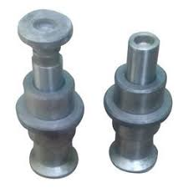The term **tappet** is widely used in relation to internal combustion **Figure # 4-1:**

**Engines**, but imprecisely. It is most commonly encountered as a maintenance task for overhead valve **engines**, that of 'adjusting the **tappets**'. ... From there it drives a long thin 'pushrod', up to the top of the **engine**, above the cylinder head as shown in figure 4-1:

**Diesel injector:**

* **Injector**, a device **for** injecting liquid **fuel** into an internal-combustion **engine**. The term is also used to describe an apparatus **for** injecting feed water into a boiler. **Four**-**stroke diesel** engine. The typical sequence of **cycle** events involves a single intake valve, **fuel**-**injection** nozzle, and exhaust valve

**Cylinder liner:**

* The cylinder liner is cast separately from the main cylinder frame for the same reasons as given for the 2 stroke engine which are:
* The liner can be manufactured using a superior material to the cylinder block.
* The cylinder liner will wear with use, and therefore may have to be replaced. The cylinder jacket lasts the life of the engine.

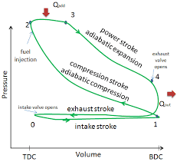**Graphical Representation:**

Graph between pressure and volume:

**Graph between temperature and entropy:**

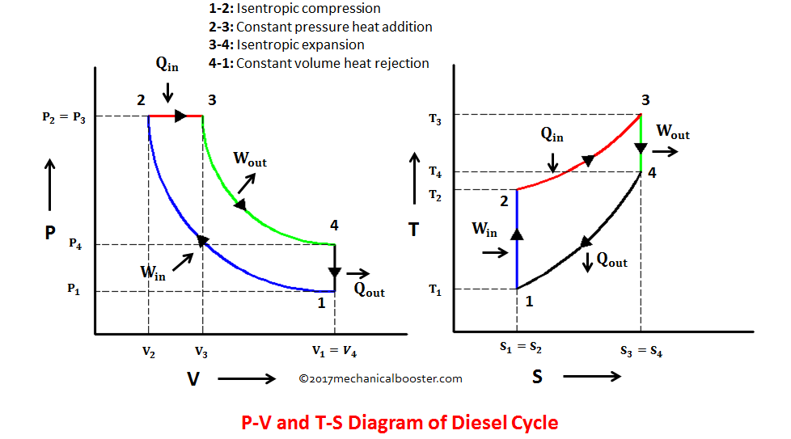

There are many **differences** between diesel and fuel engines:

* The spark plus is missing in a diesel engine. That’s because the fuel-air mixture is ignited not through a spark, but by a simple compression.
* The air drawn into a petrol engine is different in different strokes and varies in volume. But in a diesel engine, the air drawn is fixed with each stroke. There is only one inlet valve in the diesel engine. The butterfly valve and carburetor are not present in a diesel engine, unlike the petrol engine.

In order for the engine to effectively make use of this fuel:

* Fuel must be injected at the proper time, that is, the injection timing must be controlled and
* The correct amount of fuel must be delivered to meet power requirement, that is, injection metering must be controlled.

**Working of Diesel engine:**

* Actually in four stroke diesel engine, intake of air takes place. Then compression of air takes place .At the end of compression, diesel in the form of spray is injected on hot air. At the end ignition takes place.
* When we add volume, if piston is at rest, pressure increase. If piston moves downward, then pressure remains same.

**Properties:**

* Clearance volume of four stroke diesel engine is always less than two stroke petrol engine.
* Power to weight ratio of four stroke diesel engines is always less than two stroke petrol engines.

**Applications:**

* Mechanical engines
* Power generators
* Mobile drives
* Usage in locomotives
* Construction equipment
* Automobile

**Advantages of Diesel engine:**

* Diesel fuel is priced moderately higher than gasoline, but diesel has a higher energy density, i.e. more energy can be extracted from diesel as compared with the same volume of gasoline. Therefore, diesel engines in automobiles provide higher mileage, making it an obvious choice for heavy-duty transportation and equipment. Diesel is heavier and oilier compared with gasoline and has a boiling point higher than that of water.
* Diesel engines are attracting greater attention due to higher efficiency and cost effectiveness.
* A diesel engine compresses only air, and the ratio can be much higher. A diesel engine compresses at the ratio of 14:1 up to 25:1, whereas in a gasoline engine the compression ratio is between 8:1 and 12:1. After combustion, the combustion by-products are removed from the engine through the exhaust.
* They are more rugged and reliable.
* Fuel cost per Kilowatt produced is **thirty to fifty** percent lower than that of gas engines.
* Gas units burn hotter than diesel units, and hence they have a significantly shorter life compared with diesel units.

**Disadvantages of Diesel engine:**

* The major **disadvantage** associated with a **diesel** powered vehicle is the upfront cost.
* **Diesel** cars are more expensive than their gasoline powered counterparts.
* **It will cost more to repair a diesel engine.**